**NATURAL HAIRSTYLES FOR KIDS: 40 HAIRSTYLES FOR LITTLE BLACK GIRLS**

A major cause of worry for most parents, especially mothers is choosing the right kind of hairstyles for their little girls. In choosing a hairstyle, a lot of things need to be considered first, like beauty, comfort and simplicity. Kids need hairstyles that highlight their childish beauty without being over the board or too heavy. In fact, the choice of hairstyle should be one that allows your kid to be a kid, does not get in her way of play or cause her discomfort. Any hairstyle you are choosing should help your kid’s hair to grow fuller and not cause loss of hair. If your daughter’s hair is short and kinky, it shouldn’t stop you from trying any style you want. Simply add hair extensions to give her the desired design and look. The good thing is that you do not have to worry yourself about choosing the right hairstyles for your kids, as we have taken the time to put together some of the most stylish and elegant natural hairstyles for kids, that make them look classy and trendy. Take a look!

1. **Mohawks for Kids:** Different styles of Mohawks for kids, like the braided Mohawks, bun-hawks, faux-hawks and fro-hawks, have been here longer than most hairstyles and are not going out of style anytime soon. Both kids and adults alike love them because they are comfortable to rock and never go out of style. You can add more glam and style by incorporating beads and colorful hair extensions. Below are some Mohawk hairstyle samples you would definitely love on your kid!

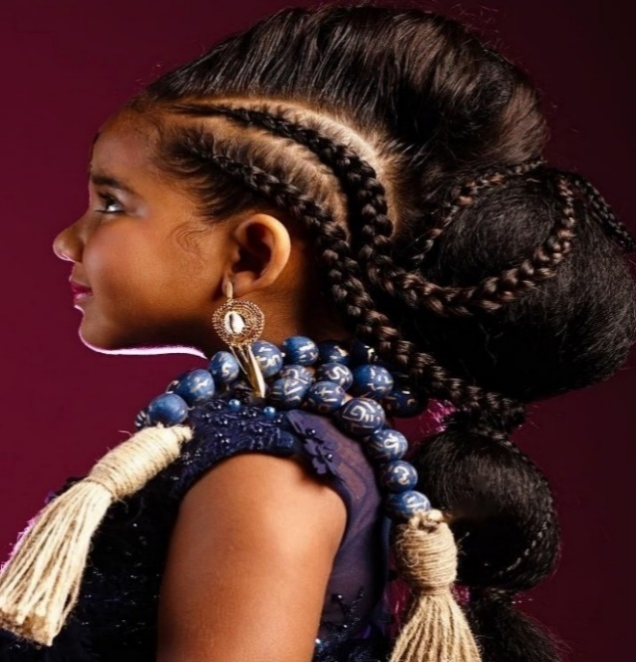 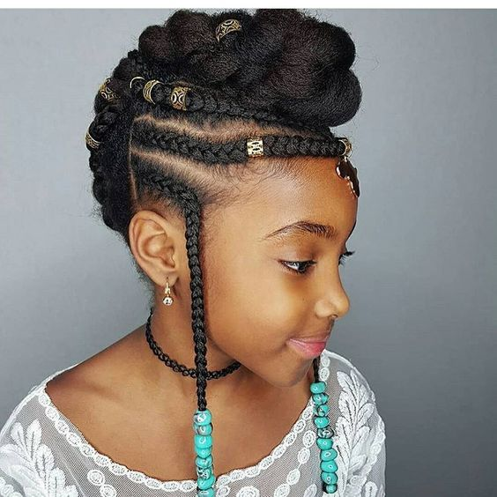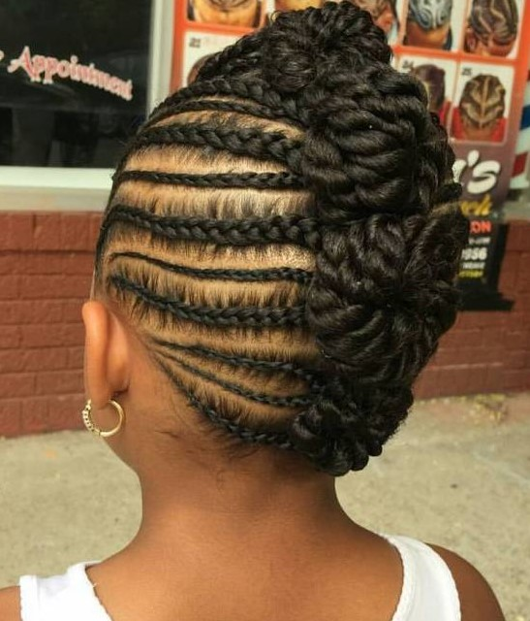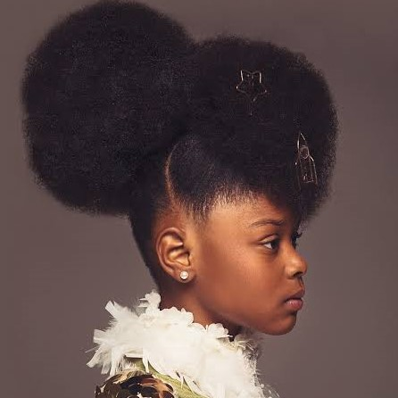  
***Image credit: creativesoulphotos.com***

1. **Bantu Knots for Kids:** In Bantu knots, you get a combination of style and simplicity. Bantu hairstyles are popular with young girls because of how unique and comfortable they are. They come in different sizes of buns and puff balls and are easy to make. You can decide to part the whole hair into beautiful twisted knots or you can have only one half of the hair knotted while the other half hangs free. To bring out the beauty of the knots, you can also hold them in place with colorful ribbons, beads or other adornments of your choice. The key is to give your kid that stylish look that would make her stand out beautifully. Take a look at some bantu knots hairstyles we know your daughter would totally love!

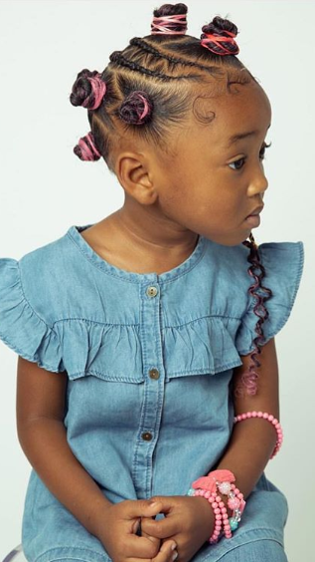 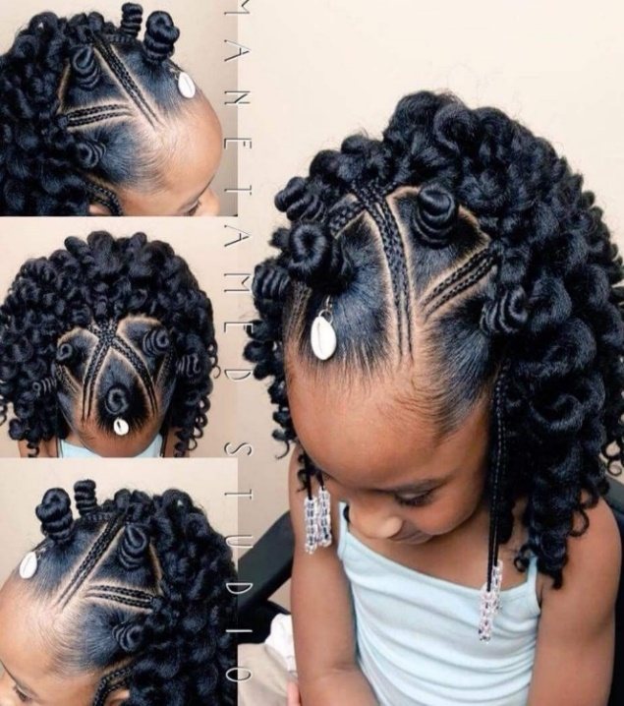

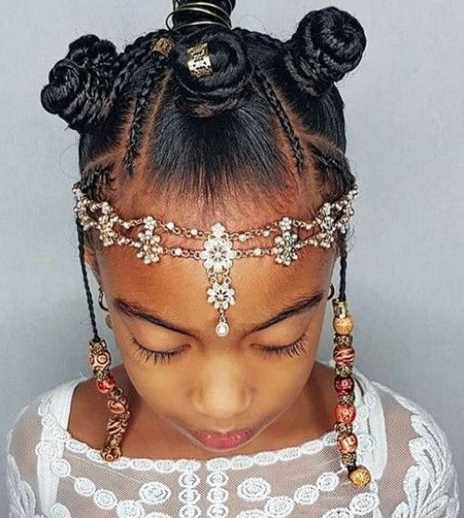 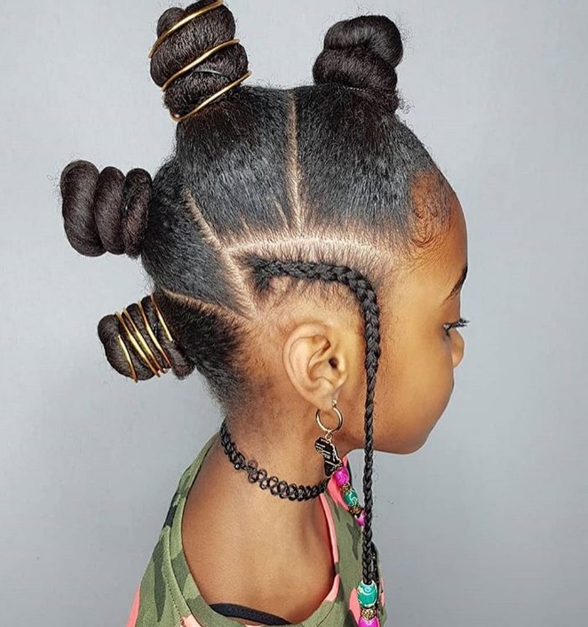

Source: Instagram

1. **Box Braids for Kids:** You can never go wrong with box braids. They are the best protective hairstyles for your daughter’s hair. They last longer than most other hairstyles when properly done by an expert hair stylist and allows you to pack them into various stylish patterns. The trick in choosing box braids for kids is to go for something classy but not too tight or heavy for your kid’s tender head. Not sure how to make the best choice of box braids for your kid’s hair? Not to worry! We have put together some samples to guide you. Have a look!

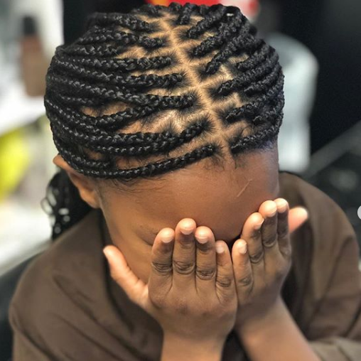 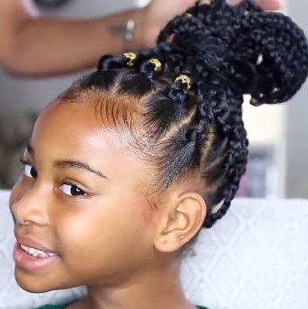

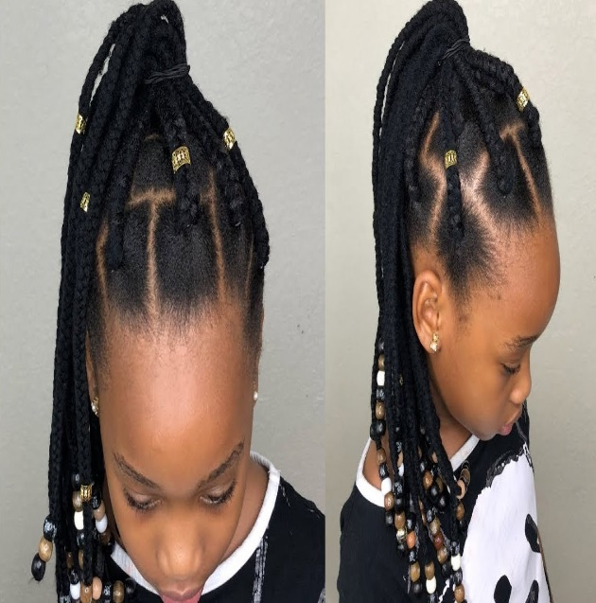 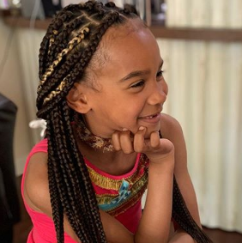

Photo credit: Instagram

1. **Updo Hairstyles for Kids:** Kids love updos because the hairstyle gives them the freedom to be and express themselves without having their hair get in the way. Updo hairstyles are easy to put together and maintain. They are beautiful and stylish in ways only they can be and they highlight your kids’ faces so well. The type of updo hairstyle you choose for your daughter should be one that complements the shape of her face, one that is comfortable enough to be elegant but not too tight as to pull on the hair and cause hair loss. You can also add hair extensions if their natural hair is too short to get the updo style you have in mind. Take a look!

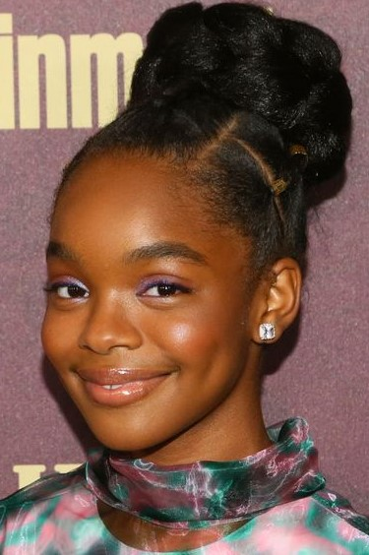 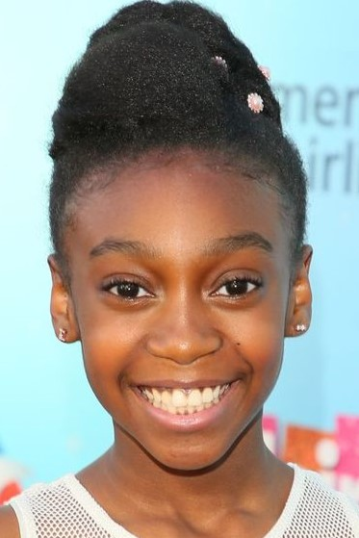

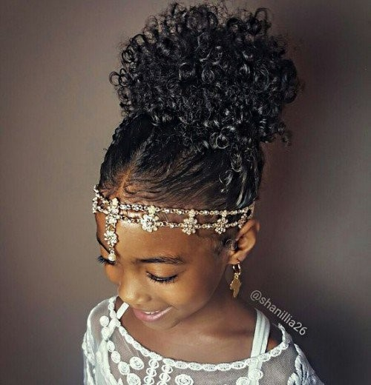 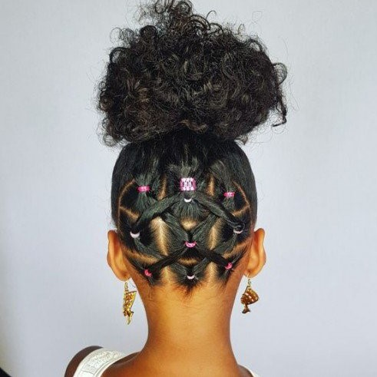

Photo credit: Instagram

1. **Braided Updos for kids:** Get creative with the updo hairstyles for your kids by adding braids. Braided updos are stylish and last longer. They provide protection for your kid’s hair as well and allow you try your hands at packing them into different styles. You can braid the whole hair and secure them into a knot at the top of the head or you can divide the braided hair into buns. There are no fast rules to braided updos, as long as your daughter comes out looking elegant and uniquely beautiful. Check out some of the braided updo hairstyles we have put together for you!

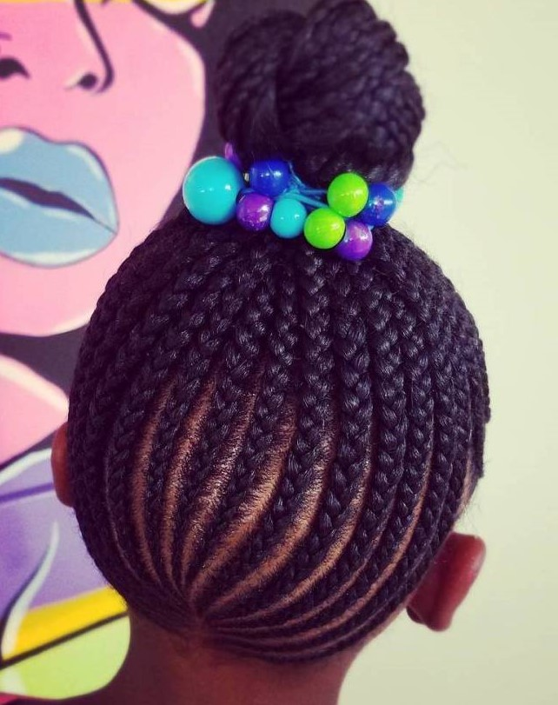 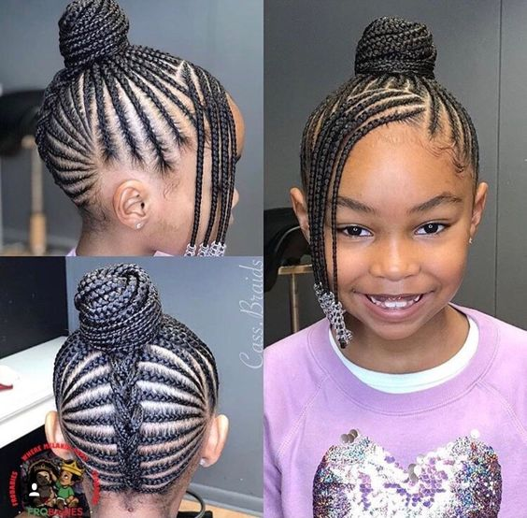

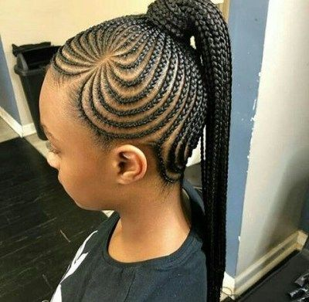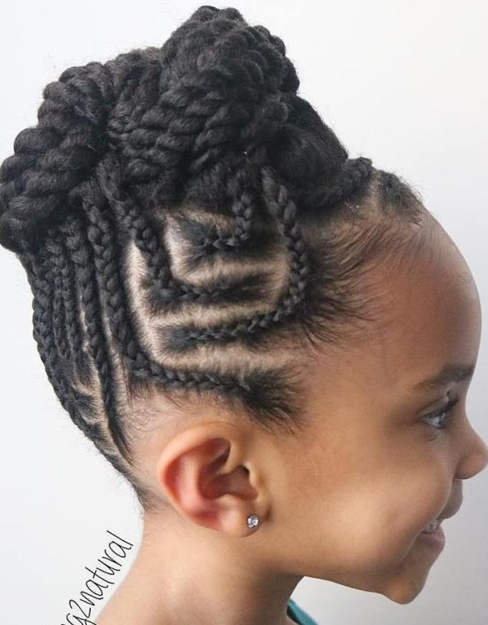

Source: Pinterest.com

1. **Adorned hairstyles for kids:** Unleash the playful side of your kid and add a dash of color and elegance to her hair by including accessories and hair adornments like colorful beads, metallic add-ons, ribbons, strings or bows. The colors are sure to make her hair come alive and make her want to show off. Not sure how to accessorize your kid’s hair? Check out the hair samples below!

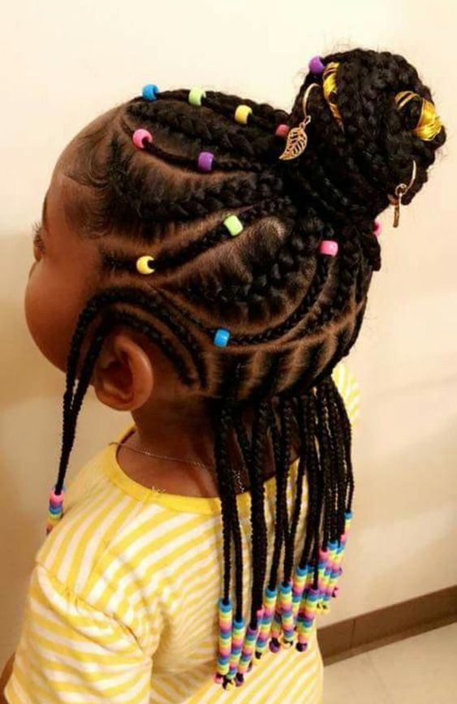 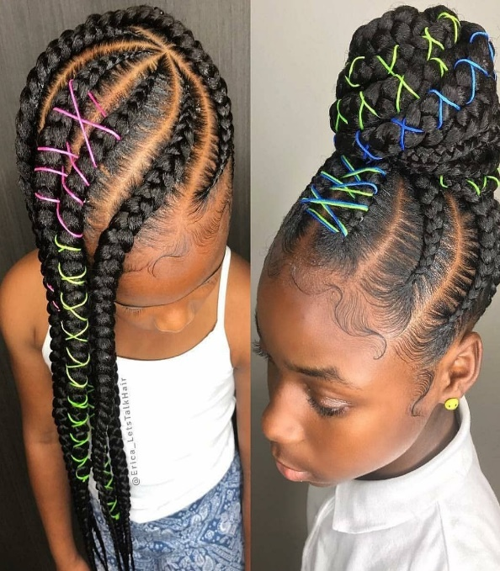

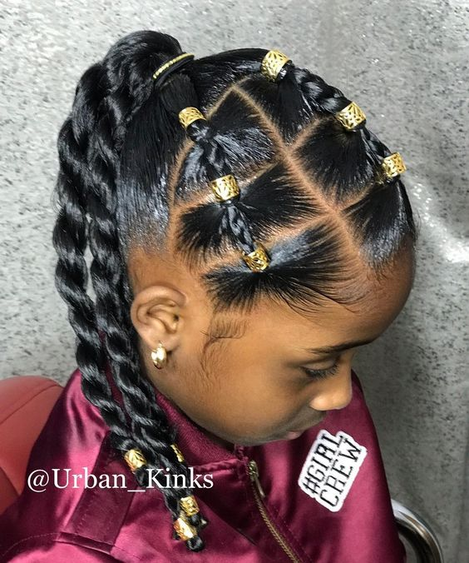 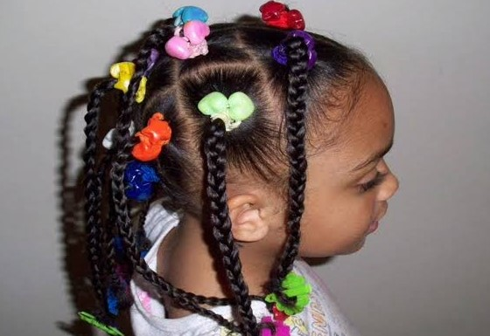

Photo credit: Urban_Kinks on Instagram

7. **Unique Hairstyles for Kids:** with a little imagination and skill, you can move away from the more common hairstyles and try hairdos that are uniquely different and creative for your daughter. In that case, the services of an expert hairstylist may be required. Like most hairstyles for kids, there are no set rules. The most important thing is to get creative and choose something unique for her. However, remember that simplicity is key and your kid’s comfort matters the most. Have a look!

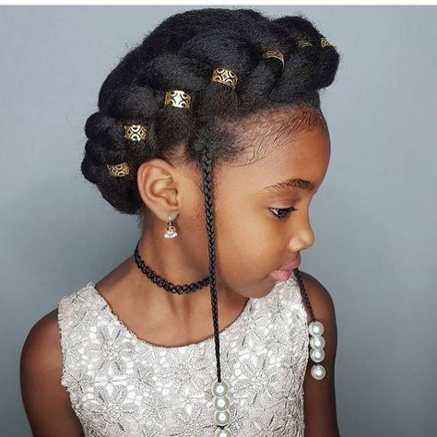 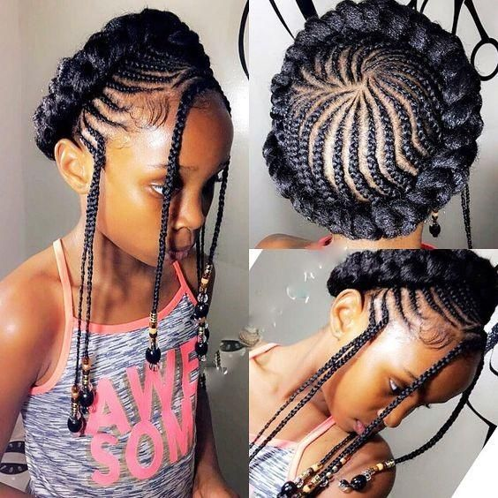

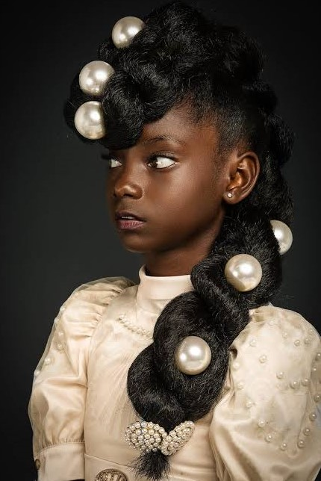 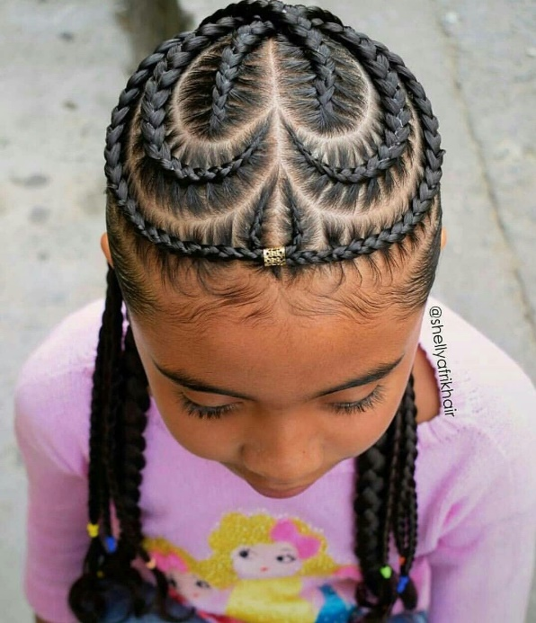

Image credit: Instagram

8. **Cornrow Braids for Kids:** Cornrows are often complicated to make, but they are comfortable to wear and offer you a wide variety of styles to try on your daughter’s hair. They are protective hairstyles and the go-to choice for kids as they can be worn anytime of the year. You can have cornrows made into ponytails or packed into topknots or braided into split buns. You can also have wide cornrows with tails that run the length of the head all the way to the back or side ponytails or center-parted pigtails and so on. The options are simply endless. Take a look at some amazing cornrow samples we have put together for you!

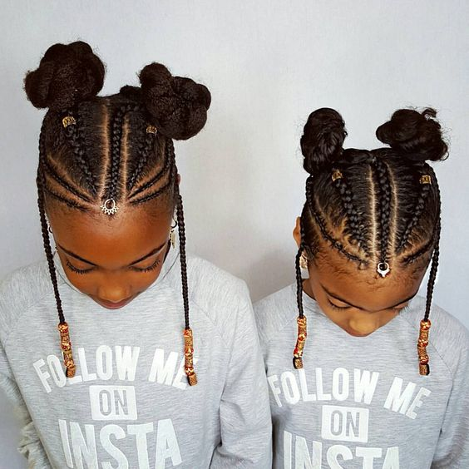 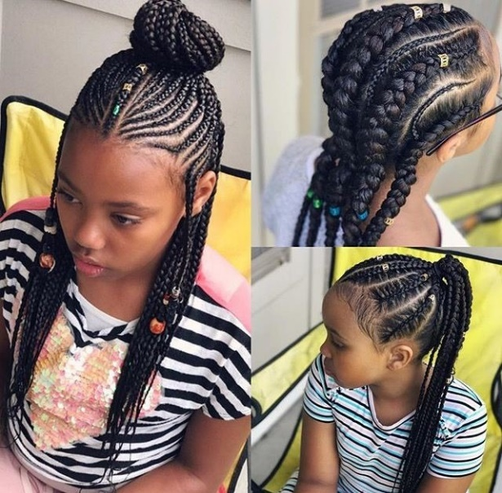

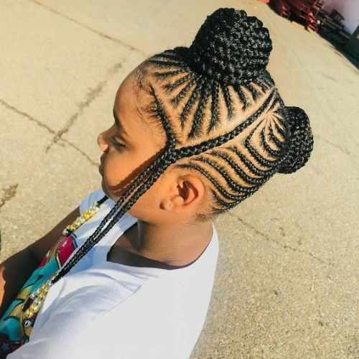 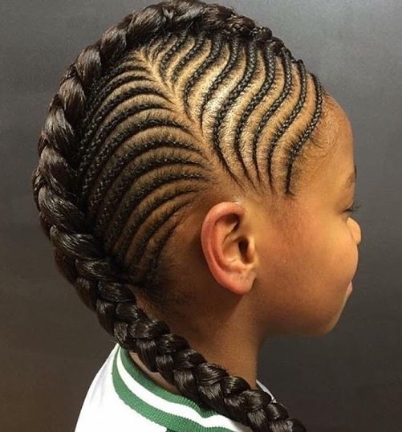

9. **Bubble Ponytails for Kids:** Ponytail hairstyles are simply stylish and look good on little girls. Varieties of ponytails exist but ponytails with bubbles offer a special kind of stylish. They highlight your daughter’s face beautifully and make her stand out. You can add a bit of elegance by styling them with beads and metallic add-ons, or braiding one half and then securing the other half in stylish bubbles. These ponytail samples will guide you on how to make the best choice of hair for your kid. Take a look!

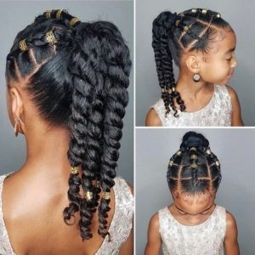 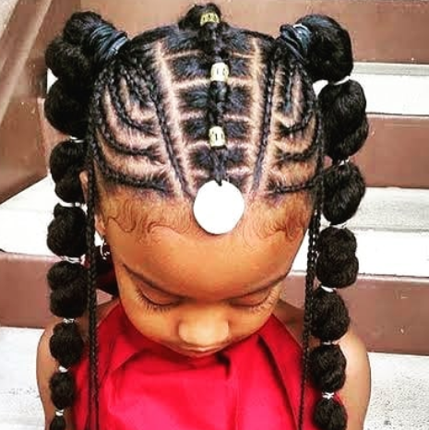

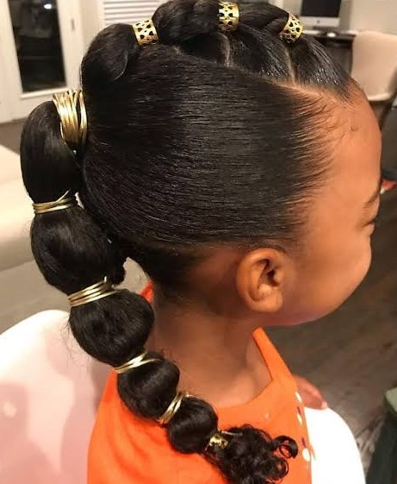 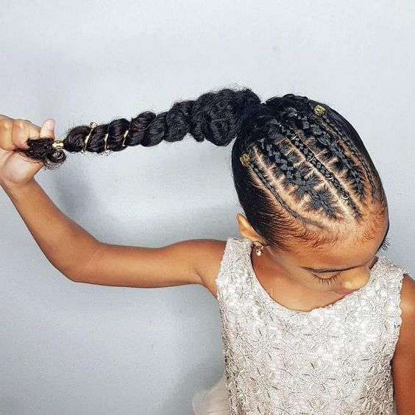

Image source: Instagram

1. **Simple Hairstyles for Kids:** Sometimes, you may want a hairstyle that is easy but yet stylish for your kid. Or you may wish to save them the trouble of sitting for hours to get their hair done. These simple but classic hairstyles are the perfect choice for you. And you don’t have to worry about your kid looking basic as these hairstyles are elegant in their simplicity. And you can do them yourself as the designs are not intricate. Check out these simple hairstyles for kids!

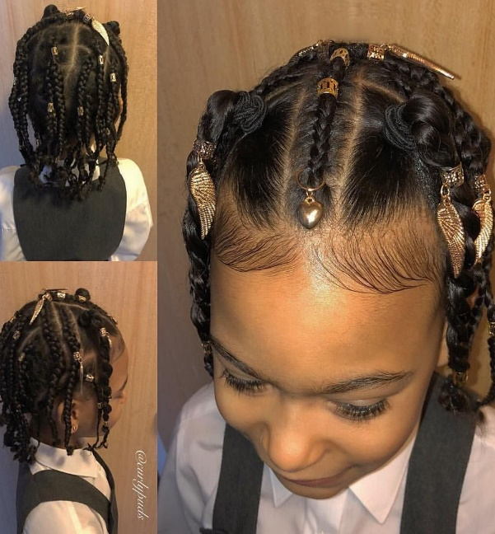 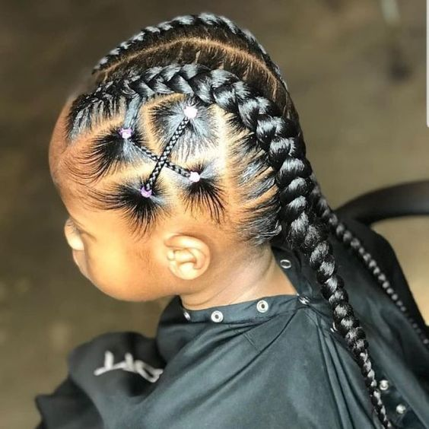

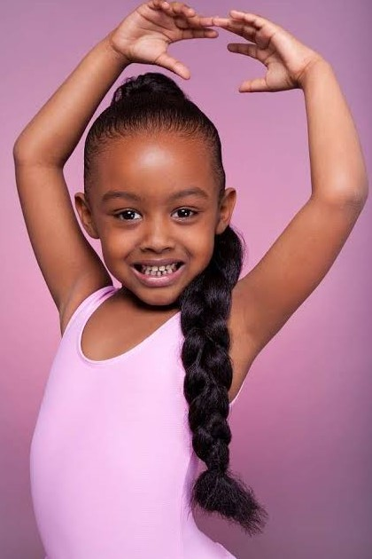 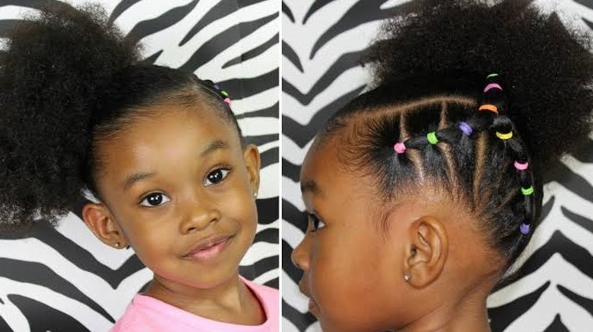

Source: Instagram

We hope you loved these hairstyle ideas we have put together for you. All the styles we have here are unique as they are beautiful. Most of them are styles you can try at home by yourself. You will only need an expert hairstylist for the more complicated designs. Remember, whatever hairstyle you decide on, be sure it offers your daughter beauty, simplicity, comfort and elegant stylishness.